The Theta Delt Times

Volume 8, Issue 1 Established October 31, 1847 January 2008
New Officers Elected for 2008-2009 Year

A new year is upon us Theta Delts, and as such, the mantle of leadership has been bequeathed to a new generation. Following is a short biography of the new officers and the skills they have brought to the table.

Inside This Issue
2 | Officer Biographies
3 | Theta Delts in Sports
4 | Theta Delts Studying Abroad
4 | Contact Information
4 | Next Issue

Theta Delts Go Abroad

This spring break, while other college students will be resting up from midterms on a beach, road-trip, or big comfy couch, four brothers of Theta Delta Chi will be enhancing their cosmopolitan and academic characters through immersion trips overseas.
Out of a highly qualified applicant pool, Anthony Tellez and Aaron Abell, class of 2010, and Jacob Surface, class of 2011, were chosen to accompany Dr. Mikesell to Israel. Once they land at the Ben-Gurion Airport near Jerusalem, they will be thrust into the highly politicized environment of the Jewish State as part of their Middle Eastern Politics class. Their trip will include guided tours of significant holy sites for Christians, Jews and Muslims alike as well as new excavations that reveal the history of this biblical land. The three lucky Theta Delts will also be spending time in the Knesset, the legislative body of Israel and will also get to spend a night in a Kibbutz, which is the traditional Zionist settlement community upon which the state of Israel was founded.

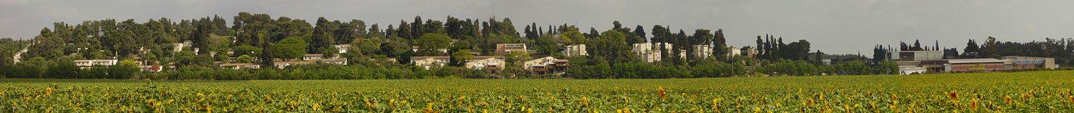

Anthony Benitez will also be enjoying an immersion trip as he will be traveling to Chiapas in southern Mexico to study in the field of Literature-Archaeo-Astronomy. His studies will focus primarily on ancient Maya history, sciences and culture. Anthony will be based in Palenque, an archaeological site which contains some of the finest, sculpture, architecture, roof comb and bas-relief carvings the Maya produced. His tour will also feature time in Yaxchilan, another empirical capital of the Maya. Yaxchilan is known for the large quantity of excellent sculpture at the site, such as the monolithic carved stone slabs and the narrative stone reliefs carved on pillars spanning the temple doorways. His trip will wrap up in the historic city of San Cristobal, Mexico.
We wish our Theta Delt brothers the best of luck and a safe journey as they travel this March.

See OFFICERS continued on page 2

See STUDY ABROAD page four

OFFICERS from page one
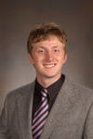 Grant Gussman, a junior from LaPorte, IN, is the newly elected President. A rhetoric major and philosophy minor, he is also the president of both College Democrats and the Debate Team. Grant was also recently initiated into the Sphinx Club.

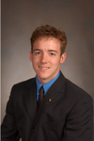 Jim Leuck, the new Vice President, is a junior from Lafayette, IN. A psychology major and Russian minor, Jim has an impressive presence on campus. He is the new president of the Inter-Fraternity Council, a new member on the Senior Council, the treasurer of Russian Club, a Recruitment Assistant for the Dean of Admissions, a member of the Edmund O. Hovey Society, and also participates in varsity swimming.

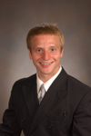 Christian Krenk, a sophomore and the new Treasurer, is also native to Lafayette. A major in chemistry and minor in biology, Christian participates in varsity soccer and various intramural sports.
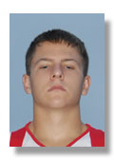 Jacob Surface, a freshman and native of Crawfordsville, is the new Corresponding Secretary of the house. A political science major and Spanish minor, Jacob is also the House Manager and Co-philanthropy Chair. On campus he acts as membership director of the College Democrats, runs on the cross country and track teams, and is on the planning committee for the Relay for Life.
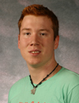 Jason Allen, a sophomore from Perrysville, IN, is the new Recording Secretary. A biology major and Spanish minor, Jason is also Scholarship Chair for the house. He is a member of the Bio Society, Woodwind Ensemble, Jazz Band, and avidly plays the piano.

Ddddddddddddd

dddddddddddddddddddddddddddddddddddddddddddddddddddddddddddddddddddddddddddddddddddddddddddddddddddddddddddddddddddddddddddddddddddddddddddddddddddddddddddddddddddddddddddddddddddddddddddddddd

Theta Delta Chi Well Represented in Sports!

Along with the multitude of intramural sports here at Wabash College, many of the brothers have pursued their passion for athletics into the varsity arena. Jim Leuck ‘09 and Kyle O’Keefe ‘08 have had a strong season thus far for the Wabash swimmers, placing third overall at the NCAC relays and dominating their dual meets, often by margins of twenty to thirty points. They will be gearing up for the NCAC Championships, held February 14 in Canton, Ohio.
Bryan Arnold ‘09 is currently enjoying the off-season before beginning summer training for the golf team which will take him to Scottsdale, Arizona May 2-9.
Although nursing a shoulder injury, Travis Stirling ‘10 has recently begun workouts for baseball, as their season begins February 23 with a game against Guilford of North Carolina.
Meanwhile, his pledge son, Luke Moreno ‘11, enjoys his early mornings with 6:00 AM football workouts. Luke, currently topping his weight class across the max lift boards, stands to see serious varsity playing time this upcoming season.
After wrapping up a successful season of cross country early this past November, Jacob Surface ‘11 ran his first race of the 2008 track and field season with a new personal record in the 3,000 meter run.
With this kind of roster, you can expect to see more Theta Delts in action across the Wabash athletic arena in the following months.



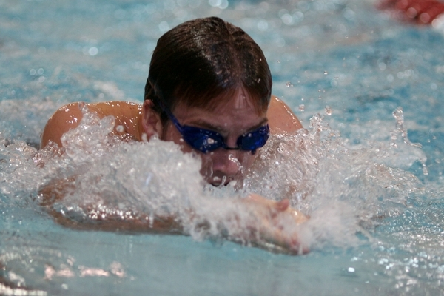

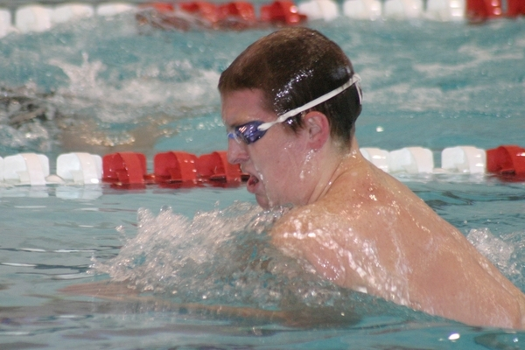



Top: Bryan Arnold ’09 drives it to the green for Wabash
Middle: Jim Leuck ’09 and Kyle O’Keefe ’08 do the breast stroke
Bottom: Jacob Surface ’11 races for the straightaway in the Wabash Hokum Karem this past cross country season

STUDY ABROAD from page one

A modern Kibbutz in the Israeli Countryside

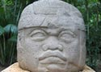

Stone relief in Palenque, Mexico

Contact Information

Grant Gussman, President gussmang@wabash.edu
Jim Leuck, Vice President leuckj@wabash.edu
Christian Krenk, Treasurer krenkc@wabash.edu
Jacob Surface, Corresponding Secretary surfacej@wabash.edu
Jason Allen, Recording Secretary allenj@wabash.edu
John McGaughey, Newsletter Coordinator mcgaughj@wabash.edu

In Next Month’s Issue

- Theta Delta Chi Leads Inter-Fraternity Council
- Newly Initiated Freshmen Brothers
- Basement Renovations: Better Late Than Never

“To establish and maintain a distinctive class of gentlemen whose strength, spirit, and brother-hood in Theta Delta Chi shall be excelled by no other.”

