Blurbs and Images for Theater Dept Season 2015-2016

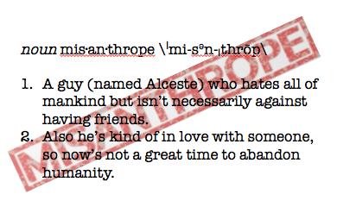

The Misanthrope
Adapted by Jessie Mills and Brian Sutow from Moliere's classic comedy
Directed by Jessie Mills
October 7-10, 2015

“It’s because I love you I won’t compromise
about all of the things you do that I despise.”

Based on Moliere’s classic rhyming comedy of manners, this playful new adaptation tells the story of Alceste, a man with an unshakeable love for one woman and a complete disdain for the rest of humanity. You see, Alceste (also known as our beloved misanthrope), despises the false niceties and duplicitous behavior of “polite society,” and wages a war against all things mannerly. But when it is revealed that his beloved might be the worst offender of all, Alceste is pushed to his limits of love and contempt…and all in rhyme.

Studio One-Acts
Original plays directed and performed by Wabash students
November 11-12, 2015
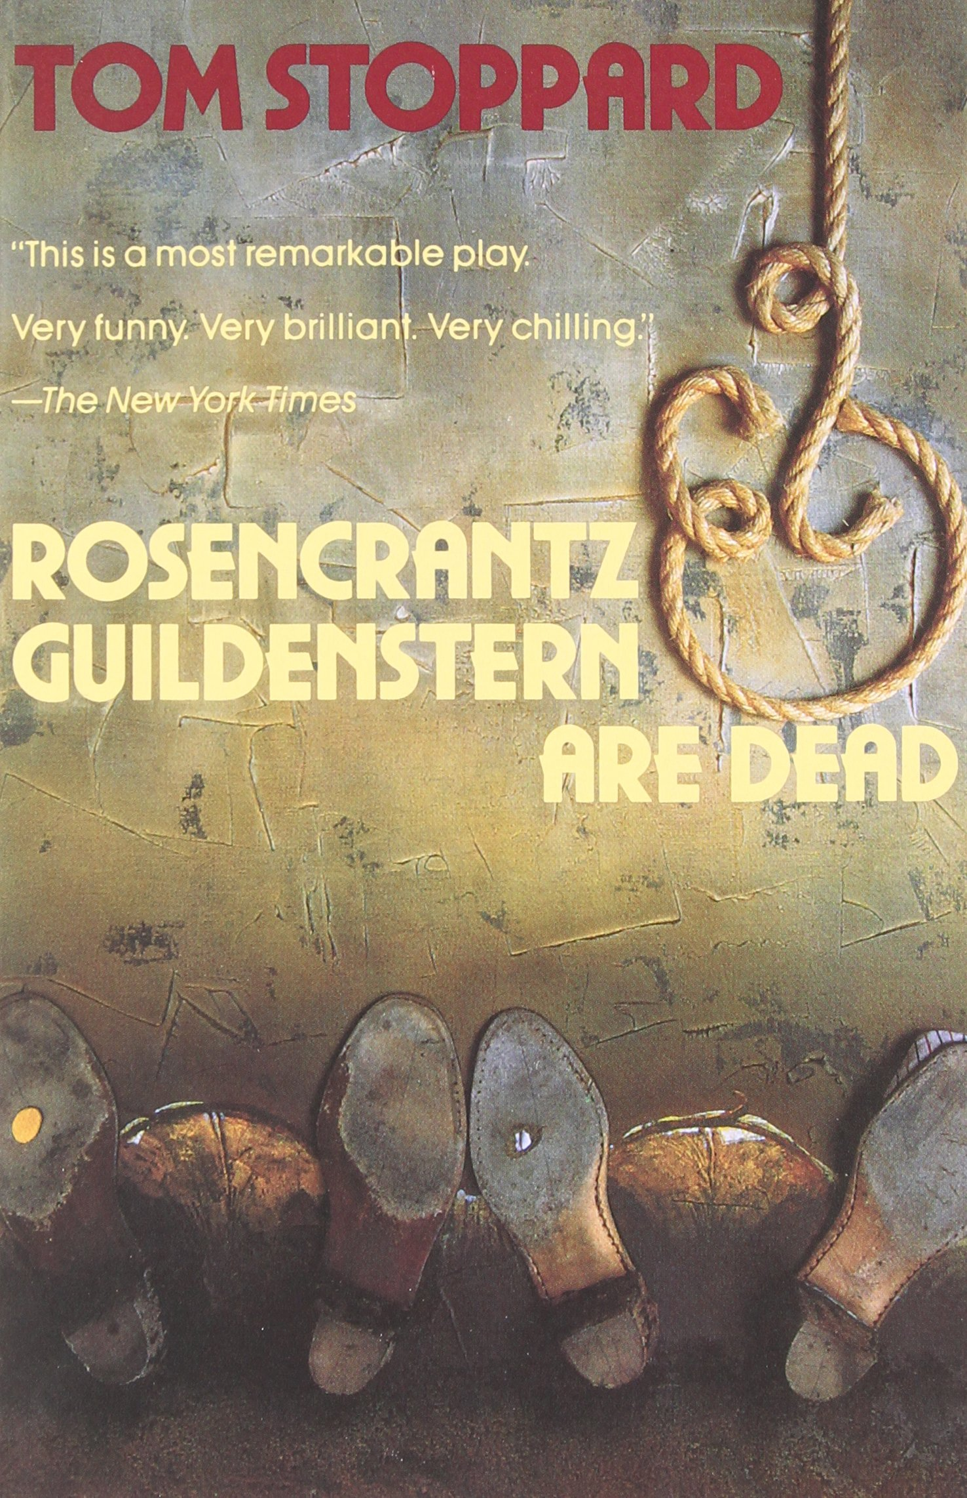
Rosencrantz and Guildenstern are Dead
by Tom Stoppard
Directed by Jim Cherry
February 24-27, 2016

On one level, Tom Stoppard’s Rosencrantz and Guildenstern are Dead is the story of William Shakespeare’s Hamlet flipped around and told from the perspective of two minor characters. But it is so much more than that: a riff on the nature of live theater, a parody of the patterns and rules of Elizabethan tragedy, a philosophical discussion on free will and the inevitability of mortality, a comedy of vaudeville slapstick and the impossibly sharp wordplay. Originating at the Edinburgh Fringe Festival in 1966, Rosencrantz & Guildenstern are Dead rocketed Tom Stoppard to mainstream acclaim and began a long string of successes including plays like The Real Thing, Arcadia, The Invention of Love, The Coast of Utopia, Rock ‘n’ Roll, and films like Brazil and Shakespeare in Love. Rosencrantz and Guildenstern are Dead went swiftly to London and Broadway in 1967, and to Wabash’s Ball Theater in 1970. A masterwork of modern drama, Rosencrantz and Guildrenstern are Dead is revolutionary, hilarious, metaphysical, tragic, and sooooooo meta.

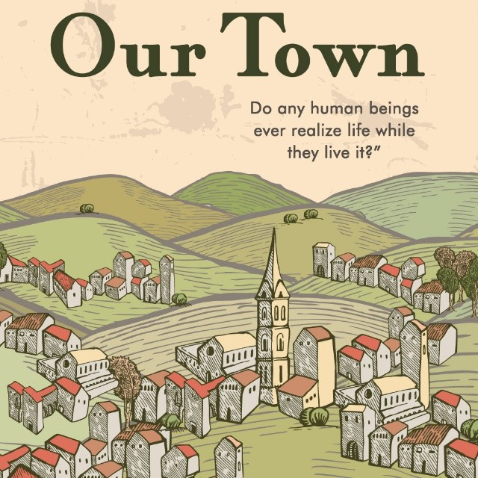

Our Town
by Thornton Wilder
Directed by Michael Abbott
April 20-23, 2016

Our Town follows the small town of Grover's Corners through three acts: "Daily Life," "Love and Marriage," and "Death and Eternity." Narrated by a stage manager and performed with minimal props and sets, audiences follow the Webb and Gibbs families as their children fall in love, marry, and eventually—in one of the most famous scenes in American theatre—die. Our Town received the 1938 Pulitzer Prize for Literature.

"Our Town is probably the finest play ever written by an American." —Edward Albee

